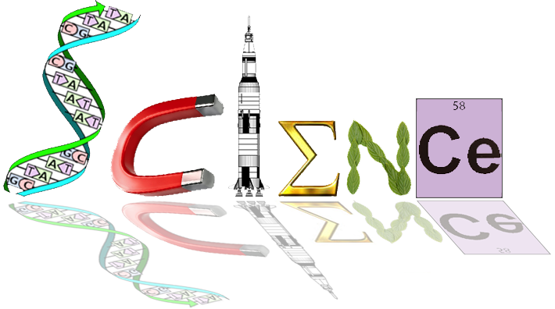

**Yr. 12 Human Biology**

**Extended Response**

**Task 7 Marking Rubric**

|  |  |  |
| --- | --- | --- |
| What vaccines actually are and the different types | * Definition (1 mark) * Outline 4 types   + Live attenuated (1 mark)   + Dead micro organisms (1 mark)   + Toxoids (1 mark)   + Sub unit (1 mark) | /5 |
| How they work in triggering an immune response and achieving immunity | * Outline of the process of building immunity   + Immune response triggered (1 mark)   + Role of b/t cells (2 marks)   + Memory cells formed (1 mark)   + Increase rate of response for future infections (1 mark) | /5 |
| The benefits for her child | * How individual immunity benefits an organism   + Less time sick due to quicker response (1 mark)   + Less chance of death due to infectious disease (1 mark) | /2 |
| How she would be benefiting Kate’s child via Herd Immunity | * Outline of Herd immunity   + Immunity levels of a population (1 mark)   + More members vaccinated means pathogens cannot spread from member to member as easily (1 mark) * Implications for vulnerable members of the herd (1 mark) | /3 |
| A discussion about the Ethical, moral and controversial aspects of the issue | * Risks   + Allergic reaction   + Cross species introduction   + Medium/preservatives may effect other parts of body   + Any two (2 marks) * Ethics   + Animal testing   + Source of human tissue   + Age of patient (HPV)   + Freedom of choice   + Any two (2 marks) * Controversy (1 mark) | /5 |
|  |  | /20 |



**Yr. 12 Human Biology**

**Extended Response**

**Task 7 Marking Rubric**

|  |  |  |
| --- | --- | --- |
| What vaccines actually are and the different types | * Definition (1 mark) * Outline 4 types   + Live attenuated (1 mark)   + Dead micro organisms (1 mark)   + Toxoids (1 mark)   + Sub unit (1 mark) | /5 |
| How they work in triggering an immune response and achieving immunity | * Outline of the process of building immunity   + Immune response triggered (1 mark)   + Role of b/t cells (2 marks)   + Memory cells formed (1 mark)   + Increase rate of response for future infections (1 mark) | /5 |
| The benefits for her child | * How individual immunity benefits an organism   + Less time sick due to quicker response (1 mark)   + Less chance of death due to infectious disease (1 mark) | /2 |
| How she would be benefiting Kate’s child via Herd Immunity | * Outline of Herd immunity   + Immunity levels of a population (1 mark)   + More members vaccinated means pathogens cannot spread from member to member as easily (1 mark) * Implications for vulnerable members of the herd (1 mark) | /3 |
| A discussion about the Ethical, moral and controversial aspects of the issue | * Risks   + Allergic reaction   + Cross species introduction   + Medium/preservatives may effect other parts of body   + Any two (2 marks) * Ethics   + Animal testing   + Source of human tissue   + Age of patient (HPV)   + Freedom of choice   + Any two (2 marks) * Controversy (1 mark) | /5 |
|  |  | /20 |